
Shieldhill Primary School Newsletter
January 2026
Respect Happiness Learning
Tel: 01324 508540
email: shieldhillprimaryschool@education.falkirk.sch.uk
School Website: https://www.shieldhill.falkirk.sch.uk/
Bluesky: @shieldhillps.bsky.social
@shieldhillelc.bsky.social
Dear Parents and Carers,
Happy New Year to everyone and welcome back to the new term which we know will be a busy one! It is lovely having the children back with us again and hearing about all of their holiday adventures!

Shieldhill Book Swap
On the first Thursday of every month we have a book swap event in school. Children are able to donate books they have read or no longer require and can choose a new book to bring home and enjoy. The next Book Swap event will be held on Thursday 8th January.
N.B. Children do not need to bring a book to take one! Keep reading everyone!
“You can find magic wherever you look. Sit back and relax all you need is a book!” – Dr. Seuss


Burns/Scots Poetry
As in previous years all classes are learning about Burns/Scots Poetry in the coming weeks. We will be having a Poetry Competition with a winner from each stage. Dae ye ken Scots? Awa’ an gie it a guid try!

Our Primary 7 pupils will also have a special Burns Celebration for their parents and invited guests on Thursday 22nd January at 6pm.


Online Learning

As you will be aware, all Primary School aged pupils have a login and password for GLOW and it would be prudent for parent/carers to check that their child is able to log in to the platform from home. Device availability and compatibility issues can be addressed with support from school staff, should this become necessary at any time. The GLOW website can be found at https://sts.platform.rmunify.com/Account/SignIn/glow.
It can also be accessed via the TEAMS app which is available in the app store. Now is the time to check if your child can access this site! If you require any support please contact the school office.

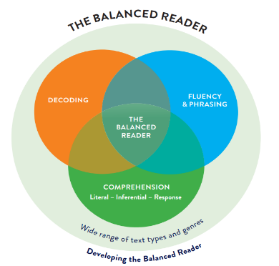
Helping Your Child to Become a Balanced Reader
We work in partnership with our parents/carers to support all learners to become ‘Balanced Readers’. To become a ‘Balanced Reader’ children need to develop skills in the following areas:
- Decoding: when a reader uses their knowledge of letters and sounds, and letter patterns to say and read words correctly’
- Fluency and phrasing: when a reader uses punctuation to break texts into meaningful segments and reads with appropriate pace.
- Comprehension: the ability of a reader to make meaning from texts using a set of skills and strategies
Staff work hard with pupils in school to teach these skills but children (P1-P7) also benefit from daily reinforcement at home to practice and consolidate what they have learned and to develop in confidence.

Every child has a ‘take home’ reader which is usually at a lower reading age level than the work they are doing with their teacher in school. Please support your child to become a ‘balanced reader’ by:
- Looking at the book cover and reading the title.
- Skimming through the book and deciding if it is fiction or non-fiction.
- Identifying any new or ‘tricky’ words before starting reading.
- Encouraging your child to have a go at self-correcting a word or sentence.
- Breaking down words into syllables to help your child to say them.
- Reading sentences with fluency (like we talk), pausing at full stops, commas and other punctuation marks.
- Using the full stops and commas to help your child to break down long sentences so they understand each part.
- Understanding each paragraph or chapter has a new idea.
- Checking that the story or information makes sense as your child is reading by predicting what might happen next in the new paragraph or chapter.
- Looking at photographs, illustrations and diagrams and reading the contents page, captions, labels and glossary to help your child make sense of the text.
- Retelling the story or information to show your child’s understanding.
- Using clues from the story or information to help your child understand any ‘hidden’ meaning.
- Taking your time with reading the whole book

Teachers regularly set reading assignments for their pupils to work on at home and share this information with parents in the child’s ‘Reading Record’. The ‘Reading Record’ is an important means of communication between the teacher and parent and although you may not feel the need to make a written comment about every assignment, I would ask that parents sign or initial ‘Reading Records’ whenever you work on reading with your child at home.
If you have any questions about supporting your child’s reading at home, or would like further information on any aspect of our curriculum, please do not hesitate to contact me.

Thank you for your continued support!

Belinda Tomasik
Headteacher

Dates for Your Diary

Date | Event
Thursday 8th January | Book Swap
Friday 16th January | P7 Braes HS Science Day
Thursday 22nd January | P7 Burns Celebration 6pm
Friday 13th – Monday 16th February | Mid Term Holiday
Tuesday 17th February | In Service Training Day for Staff – Pupils do not attend

