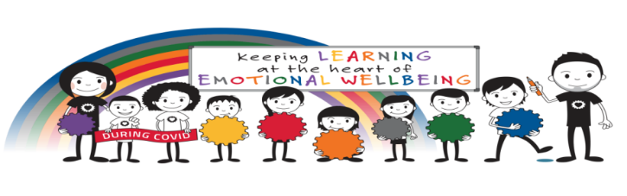
Shieldhill Primary School Parent Information – Emotion Works
Dear Parent/Carer,
This session we have introduced the Emotion Works Programme with all children from Nursery to Primary 7. This programme is used to ensure our children are happy, settled, confident and ready to learn. We would like to share some information about the programme and how it is used within our school

What is Emotion Works?
Emotion Works is a practical and colourful educational programme designed to help children to:
• learn emotional language
• develop emotional understanding
• manage and regulate their emotions
The Cog Model
The programme is based on the ‘Cog Model’ which breaks the topic of emotion down into 7 different parts, but also shows how each part links together to help children understand their emotions and how they can express and manage them in a healthy way.
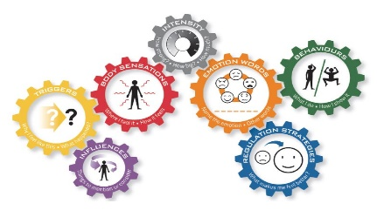
Understanding about the 7-cog model is tricky, but by upper primary most children can use it to talk and learn about emotions in stories and real life to help learning. With very young children, we teach language that will help them to talk and learn about emotions as they grow older. The language resources match the cog colours and can be used for cog learning too.

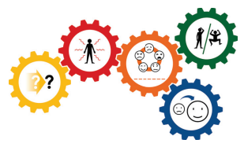
With younger pupils it’s easier to teach about these 5 cogs first. We can talk about emotion in stories, songs, art, and real-life to help learning. This is the main model Primary Schools introduce to all learners and could also be used at home...

Using the 5 Cogs at Home
If your child is interested in sharing their Emotion Works learning at home, parents/carers can use the 5 Cog poster (at the end of this leaflet) as the basis for emotion conversations.

When you, your child or someone else in the family has an emotional response to something, you could use the cogs to help notice what’s happening in the moment or talk about it after it happened. You could also use the cogs to talk about how characters feel in books, movies or on TV. It also works for observing people in real life, on the news, playing sports, on holidays etc.



How to talk about each of the cogs with your child

 | Orange cog – Emotion Words - name it  Which emotion word best describe how you feel? Or the other person / character. You might need to make some suggestions to move beyond ‘happy’ or ‘sad’.
 | Red Cog – Body Sensations - notice and describe the sensation  Acknowledge how it feels inside – where do you feel it in your body? What does it feel like? (e.g. in my tummy, tense muscles, dry mouth)
 | Yellow Cog – Emotion Triggers - knowing triggers and causes  Ask - What made you feel this way? Why are you...? Was it because...? (there are lots and lots of reasons why we feel different emotions!)
 | Green Cog – Emotion Behaviours -our behaviours when we’re feeling emotional  What did you do to show this feeling to others? (Using your face, body, actions, words). Is this behaviour ok? What else could you do?
 | Blue Cog – Regulate to feel better  What things (strategies) could you do to calm down, cheer up or feel safer? Again, you may need to make suggestions.

What now?
In school, we are now refining many of our programmes and practices to reflect the Emotion Works Cog Model. This will ensure consistency with regards to our Health and Wellbeing curriculum, Positive Behaviour Strategy, and our Restorative Approach to conflict resolution. More information will be made available shortly but in the meantime, please do not hesitate to contact a member of staff if you have any further questions regarding Emotion Works.

